**2 Nov 2018** **The Weekly Bulletin of Rotary Club of Kathmandu Mid-Town** **bc-8.11/018**

|  |
| --- |
| C:\Users\Public\Documents\RIP T1819_EN.png |

District: 3292 Web:www.rotarymidtown.org.np Club Id: 26776

**NOVEMBER IS ROTARY FOUNDATION** **MONTH**

The mission of The Rotary Foundation is to enable Rotarians to advance world

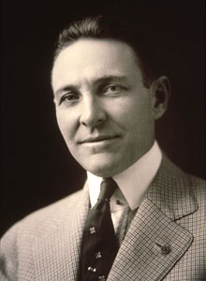

understanding, goodwill, and peace through the improvement of health, the support

of education, and the alleviation of poverty.

To commemorate the November theme, here are a few tips:

- Open each club meeting with a Rotary Foundation thought;

- Dedicate some club meetings to Rotary Foundation topics;

- Encourage every Rotarian to personally contribute to the Foundation’s

Annual Fund every year;

- Lead by example: Make your own Annual Fund contribution toward achievement

of your club’s annual giving goal and annual Foundation club banner recognitions; PRI P Arch C. Klumph

- Plan a special Rotary Day and invite everyone in your community to participate;

- Thank and honor Major Donors, Paul Harris Society members, Bequest Society members, Benefactors,

at every opportunity.

**Club Meeting # 1462** : 26 Oct 018

Guest speaker Sarik Bogati, receiving a certificate of appreciation from Club President Jo.

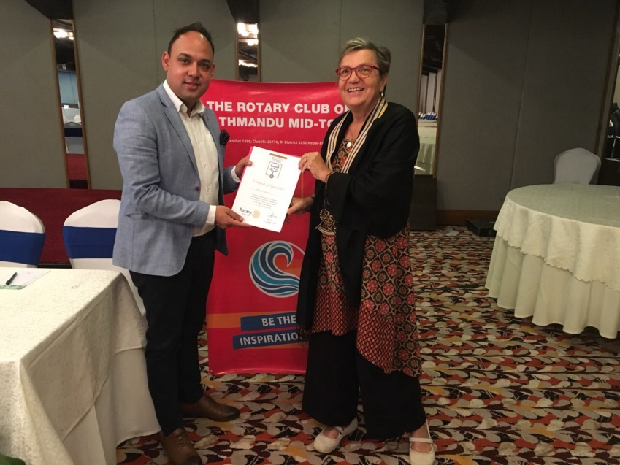

*Photo courtesy: Rtn Shyam R Thapalia*

# Weekly Meeting/Program Schedule:

|  |  |  |
| --- | --- | --- |
| Date | Program/ Speaker | Topic of Presentation |
| 2 Nov 2018 | Dr. Kulesh B Thapa (Former DIG Police) | Nepal Ambulance Service |
| 9 Nov 2018 | No meeting | Holiday: Bhai-Tika |
| 16 Nov 2018 | Celebrate Charter Night |  |
| 23 Nov 2018 | TBA |  |
| 30 Nov 2018 | TBA |  |
| 7 Dec 2018 | Club Assembly |  |
| 12 Dec 2018 | DG Visit |  |

Friday Meeting: 2 Nov

Our PE Neeva Pradhan will provide briefings on on-going Vocational Training program for youth - college students, Mid-Town Rotaracts and volunteers from Art of Living. The first and second part of this training program is already over, and the third/final part is going to be held on Tuesday, 6 Nov at Xavier Academy, Lazimpat.

Following the briefings, guest speaker Dr Kulesh Bahadur Thapa, will provide his presentation on Nepal Ambulance Service and its first aid training approach.

Dr. Kulesh B Thapa is a medical doctor (Paediatrician). Before retirement he was working in Nepal Police Hospital holding the rank of Deputy Inspector General of Police and was involved in most of the natural and man made disasters in Nepal. His particular area of expertise is disaster management.

**Happy Tihar**

** 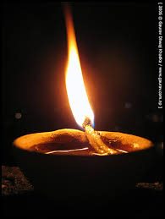 **

**HAPPY TIHAR 2075**

**On the auspicious occasion of Happy Tihar**

***May Almighty Goddess MahaLuxmi***

**bestow Her *blessings* to all Mid-Towners**

**for peace and happiness.**

**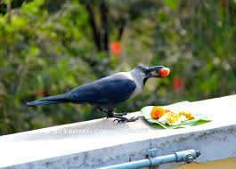 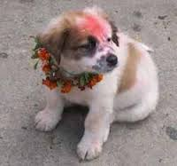 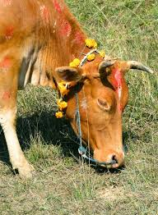  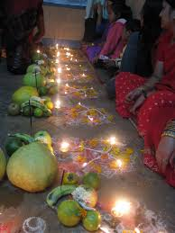 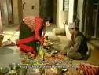**

*Kaag-puja Kukur-puja Luxmi-puja Mha-puja Kija-puja*

**Tihar** ([Nepali](http://en.wikipedia.org/wiki/Nepali_language): तिहार) is a five-day-long [Hindu](http://en.wikipedia.org/wiki/Hindu) festival celebrated in [Nepal](http://en.wikipedia.org/wiki/Nepal) which comes soon after [Dashain](http://en.wikipedia.org/wiki/Dashain" \o "Dashain). Similar to [Deepawali](http://en.wikipedia.org/wiki/Deepavali) but with a regional variation. In [Nepal](http://en.wikipedia.org/wiki/Nepal) all Hindu ethnic groups celebrate this festival with their own variation . Among the [Newars](http://en.wikipedia.org/wiki/Newar" \o "Newar), it is known as [Swanti](http://en.wikipedia.org/wiki/Swanti_(festival)" \o "Swanti (festival)). The festival is celebrated from Trayodashi of Kartik Krishna to Kartik Shukla Dwitiya every year. Tihar in general signifies the festival of lights, where diyas are lit both inside and outside the houses to make it illuminate at night. The five-day festival is considered to be of great importance as it shows reverence to not just the humans and the Gods, but also to the animals like crow, cow and dog, who maintain an intense relationship with the humans.

**A THOUGHT FOR THE DAY:**

**Have the courage to say ‘no’. Have the courage to face the truth. Do the right thing because it is right. These are the magic keys to living your life with integrity.**

*William Clement Stone*

**Committee Chairs’ Column:** *(This column is for use by chairpersons of 5 permanent committees: Club Administration, Membership, Public Relations, Service Projects, and the Rotary Foundation)*

**Members’ Corner:** *(This column is for Club members to express anything they would like in matter of Club activities, Club administration, Club issues or on Breakfast Chatter, or on anything else that would be of interest to fellow members.)*

.

## Thought on TRF

## Our investment in time, talent and financial resources are an investment in making the world a safer and healthier place for our children and grandchildren.

**Do you know?**

To celebrate its 100th year, The Rotary Foundation has recognized 20 global grants that exemplify what a project should be: a sustainable endeavor that aligns with one of Rotary’s areas of focus and that is designed in cooperation with the community to address a real need. These noteworthy projects demonstrate how your club can leverage the resources of the Foundation to do good in the world.

*Source: Rotary.org*

On Lighter Side:

A plumber attended to a leaking water tap at a neuro-sugeon's house.

After a 2-minute job, he demanded $75.

"I don't charge this amount even though I'm a surgeon."

"You're right, that's why I switched from surgery to plumbing!"

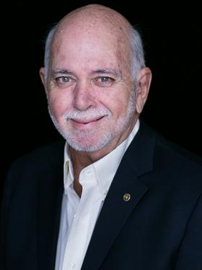

The Rotary Foundation has talked about sustainability for a long time. To be sustainable – to make

the good we do last – you should be transformational, so that fits well into what the Foundation

Trustees and global grants are doing. The districts could look at district grants and do the same kind

of thing. We have the resources. We just have to think a little differently.

**RI President Barry Rassin**

Please send information on club activities, progress reviews on service projects, relevant photos etc to:

BC Editor: RR Shrestha email: rryesrr@gmail.com

## 2 Nov 2018 The Weekly Bulletin of Rotary Club of Kathmandu Mid-Town bc-8.11/018